Ex.No 4
Write a python program to implement linear models to approximate the given data Aim:
To implement linear model in order to approximate the given data.

Procedure:
- Import the necessary libraries import numpy as nm
import matplotlib.pyplot as mtp import pandas as pd

- Load the dataset

data_set= pd.read_csv('Salary_Data.csv') data_set
- Extract dependent and independent variable from the dataset x= data_set.iloc[:, :-1].values
y= data_set.iloc[:, 1].values x,y

- Construct training and test dataset
from sklearn.model_selection import train_test_split
x_train, x_test, y_train, y_test= train_test_split(x, y, test_size= 1/3, random_state=0) x_train,x_test,y_train,y_test

- Fit the simple linear regression to training set

from sklearn.linear_model import LinearRegression regressor= LinearRegression()
regressor.fit(x_train, y_train)

- Predict the test set result

y_pred= regressor.predict(x_test) x_pred= regressor.predict(x_train)

- Visualize the training set result

mtp.scatter(x_train, y_train, color="green") mtp.plot(x_train, x_pred, color="red") mtp.title("Salary vs Experience (Training Dataset)") mtp.xlabel("Years of Experience") mtp.ylabel("Salary(In Rupees)")
mtp.show()

- Visualize the test set result

mtp.scatter(x_test, y_test, color="blue") mtp.plot(x_train, x_pred, color="red") mtp.title("Salary vs Experience (Test Dataset)") mtp.xlabel("Years of Experience") mtp.ylabel("Salary(In Rupees)")
mtp.show()

Sample Output:
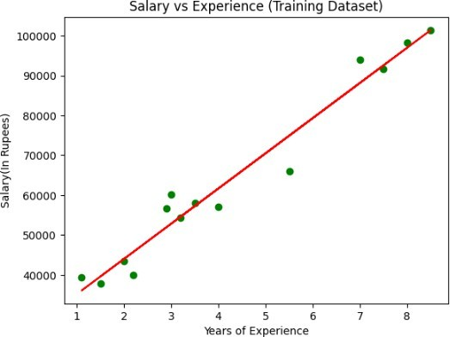

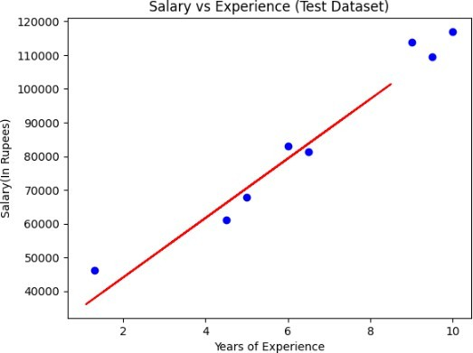

Data Set:

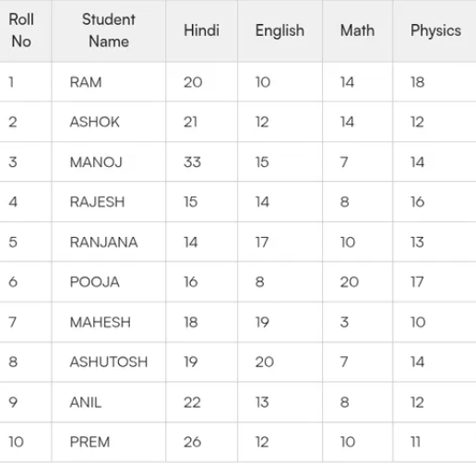
CODING:

import numpy as np
import pandas as pd
import matplotlib.pyplot as plt
from sklearn.linear_model import LinearRegression
df = pd.read_csv("Student_Marks_Data.csv")
print("Dataset Preview:")
print(df.head())
X = df.iloc[:, 2].values.reshape(-1, 1)
y = df.iloc[:, 5].values
data_combined = pd.DataFrame(np.hstack((X, y.reshape(-1, 1))), columns=['X', 'y'])
data_combined.dropna(inplace=True)
X = data_combined['X'].values.reshape(-1, 1)
y = data_combined['y'].values
model = LinearRegression()
model.fit(X, y)
X_test = np.linspace(X.min(), X.max(), 100).reshape(-1, 1)
y_pred = model.predict(X_test)
plt.scatter(X, y, label='Actual Data')
plt.plot(X_test, y_pred, label='Regression Line')
plt.xlabel('Hindi Marks')
plt.ylabel('Physics Marks')
plt.title('Linear Regression: Hindi vs Physics')
plt.legend()
plt.show()

Output:

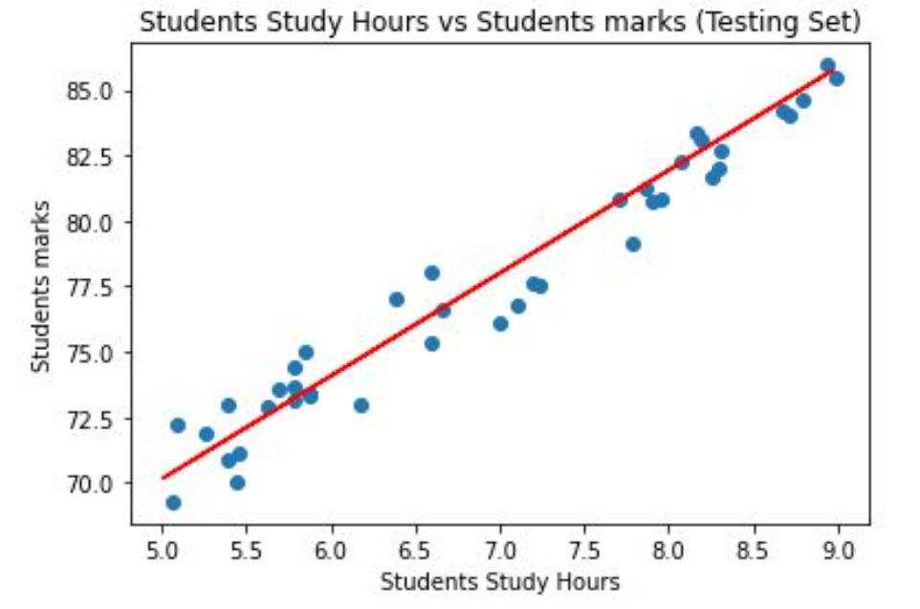

MARK ALLOCATION
Conduct of Experiment(30)
Record Observation (20)
Viva (10)
Total (60)
Signature of the Faculty with Date

Result:
Thus the linear model is implemented to approximate the given data.

